|  |  |
| --- | --- |
| cetlogo ***CHEMICAL ENGINEERING TRANSACTIONS***  ***VOL. xxx, 2025*** | A publication of  aidiclogo_grande |
| The Italian Association  of Chemical Engineering  Online at www.cetjournal.it |
| Guest Editors: Fabrizio Bezzo, Gabriele Pannocchia, Almerinda di Benedetto  Copyright © 2025, AIDIC Servizi S.r.l. **ISBN** 979-12-81206-17-5; **ISSN** 2283-9216 | |

Cookie Enriched with Quinoa (*Chenopodium quinoa*) and Enzymatic Hydrolysate of Anchovy (*Engraulis ringens*) to Overcome Anemia and Malnutrition

Sinforosa L. Pomaa, Paula A. Sancheza, Robert S. Suareza, Rosario M. Isidroa, Eva M. Vargasa, Criss L. Topalayaa, Magaly H. Chambillaa, Jorge H. Jhonconb\*

aDepartamento de Educación en Industrias Alimentarias y Nutrición. Facultad de Agropecuaria y Nutrición. Universidad Nacional de Educación Enrique Guzmán y Valle. Avenida Enrique Guzmán y Valle Nº 951, La Cantuta-Chosica. Lima. Perú.

bCentro de Investigación en Agricultura Orgánica. Centro de Investigación de Plantas Aromáticas y Medicinales. Universidad Nacional de Educación Enrique Guzmán y Valle. Avenida Enrique Guzmán y Valle Nº 951, La Cantuta-Chosica. Lima. Perú.

[\*Corresponding author: jjhoncon@une.edu.pe](mailto:*Corresponding%20author:%20jjhoncon@une.edu.pe)

Iron deficiency anemia is a scourge that ravages the world and especially preschool children. In this regard, Peru is not immune to this problem, so this study aims to investigate the consumption of hydrolyzed anchovy cookies and anemia in children under 3 years of age in educational institutions in Chosica. The methodology used in the research was the quantitative approach and the instruments used were the blood count for the diagnosis of anemia and the daily consumption of cookies enriched with quinoa and enzymatic hydrolysate of anchovy. Their chemical, physical, and microbiological characteristics were analyzed, as well as the sensory evaluation.

Finally, the study included a more in-depth sensory evaluation of the cookies in order to prevent their rejection. The study then inferred that the addition of enzymatic hydrolysate of anchovy improves the nutritional value of the cookies. And, the inclusion of food education and the consumption of cookies enriched with anchovy hydrolyzate are barriers against the appearance of anemia. The results indicate that the hemoglobin level increased in all children and that the strategy of talks and workshops with parents, teachers and students is a positive strategy that has allowed the development of research with the participation of the actors in the educational process.

**Keywords:** Food Education, quinoa, kiwicha, cañihua, anchovy hydrolysate, anemia

* 1. Introduction

According to the World Health Organization, anemia is a disease in which the number of red blood cells, or the concentration of hemoglobin in red blood cells, is lower than normal, which mainly affects women and children. Worldwide, it is estimated that 40% of children aged 6 to 59 months, 37% of pregnant women and 30% of women aged 15 to 49 years suffer from anemia.

Peru is no stranger to anemia and in this reality, the results of the 2019 Demographic and Family Health Survey (ENDES) showed that the national average was 40.1%. In Figure 1, it can be seen that the Puno Region has 70% anemia, being the center of origin of high Andean cereals such as quinoa (Chenopodium quinoa), kiwicha (Amaranthus caudatus), and cañihua (Chenopodium pallidicaule). These facts are incomprehensible in a country like ours, which is among the five most megadiverse countries in the world and has made important contributions to global agriculture and nutrition.

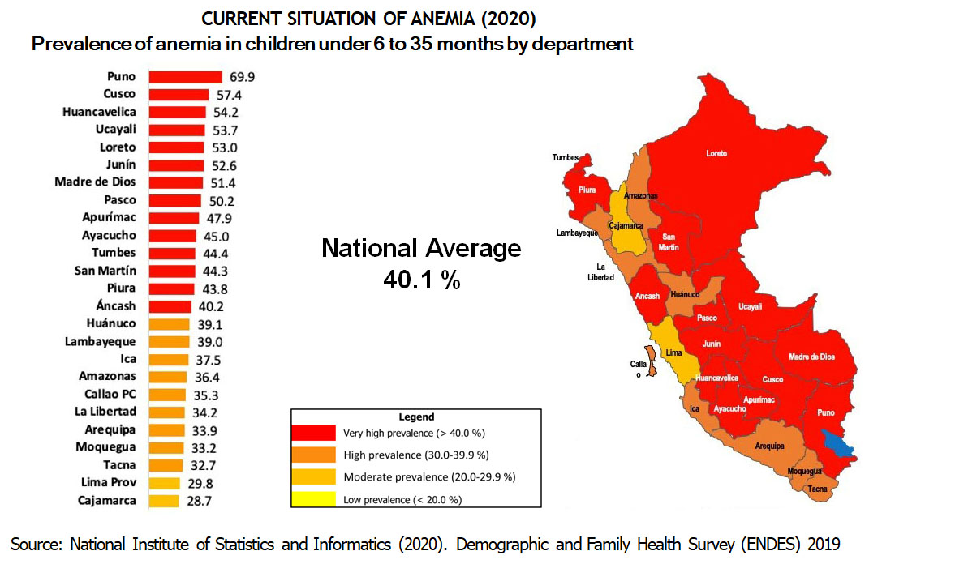

One explanation for this phenomenon is that the media has imposed a dietary model based on processed foods called junk food. This is made worse by the fact that educational institutions direct the consumption of this type of food from school, leaving aside a diet based on natural and organic food products and the consumption of healthy foods produced by the community.

According to the first academic dialogue: Peruvian biodiversity products to prevent anemia, held on May 23, 2019 and organized by the Ministry of the Environment, anemia was defined as a condition that occurs when the hemoglobin index in the blood is below an expected limit and is insufficient to meet the needs of the body, which vary depending on age, sex, altitude above sea level where the person lives, and the different stages of pregnancy (Kanak M. et al, 2019; Getachew et al., 2019). Likewise, anemia can be caused by other nutritional deficiencies (including folate, vitamin B12, and vitamin A), acute and chronic inflammation, parasitosis, and hereditary or acquired diseases that affect hemoglobin synthesis and the production or survival of red blood cells (Odunlade et al, 2018).

At the mentioned event, we presented the research entitled: Cookies Enriched with Quinoa (Chenopodium quinoa), Tarwi (Lupinus mutabilis) and Moringa (Moringa oleífera) to raise the nutritional level of the first grade students of secondary education of the Felipe Santiago Estenos Educational Institution of Chaclacayo and the Pablo Patrón Educational Institution of Lurigancho - Chosica, and later we have included a Fish Protein Concentrate (CPP) obtained from the enzymatic hydrolyzate of anchovy (Engraulis ringens), yellowfin tuna (*Thunnus albacares*) and other species of our Peruvian sea.

In our country, two of the main causes of anemia are: low consumption of heme iron from animal sources, as well as the high presence of infectious diseases (Zavaleta and Astete, 2017). Consequently, anemia is accentuated by economic, social and cultural inequalities, which manifest themselves in poverty, poor housing conditions (especially with regard to access to water and sanitation), lack of knowledge of families about the importance of healthy eating and hygiene practices, among other factors (Zavaleta and Astete, 2017).

The validation of the cookie enriched with high Andean grains and enzymatic hydrolysate of anchovy was carried out at the Mis Angelitos I early childhood education institution. The classroom of 36-month-old children had 16 children. With the consent of the parents, permission was obtained to analyze the hemoglobin level at the beginning and end of the research, except for one child, because the family was vegan and therefore this child did not receive the cookie. After the scope of the project was explained, the parents signed the informed consent form.

* 1. Materials and Methods

**Cookie Ingredients**

The cookie enriched with enzymatic hydrolysate of anchovy, basically includes wheat flour (Triticum spp.), quinoa (Chenopodium quinoa), kiwicha (Amaranthus caudatus), cañihua (Chenopodium pallidicaule), essential oil of passion fruit (Passiflora edulis)

The preparation of the cookies was carried out according to the formulation worked on in validation research of cookies enriched with enzymatic hydrolysates of yellowfin tuna (*Thunnus albacares*) (Poma et al. 2023)

The biscuit was prepared in the product preparation laboratory of the Faculty of Agriculture and Nutrition and the physical, chemical and microbiological analyses were carried out in the Total Quality laboratory of the National Agrarian University La Molina (UNALM).

**Enzymatic hydrolysate of anchovy**

The anchovy hydrolysate production process consists of three main stages: a pre-treatment which consists of forming a homogenized water-muscle mixture (Khantaphant, Benjakul & Ghomi, 2011); a second stage, hydrolysis, in which the paste and the enzyme are mixed in a known ratio at a given time, pH and temperature; the enzyme is then inactivated by heat, generally at 90°C for 30 minutes. Finally, centrifugation separates the fatty phase from the protein phase and the latter is dried to obtain the hydrolysate (He et al., 2013).

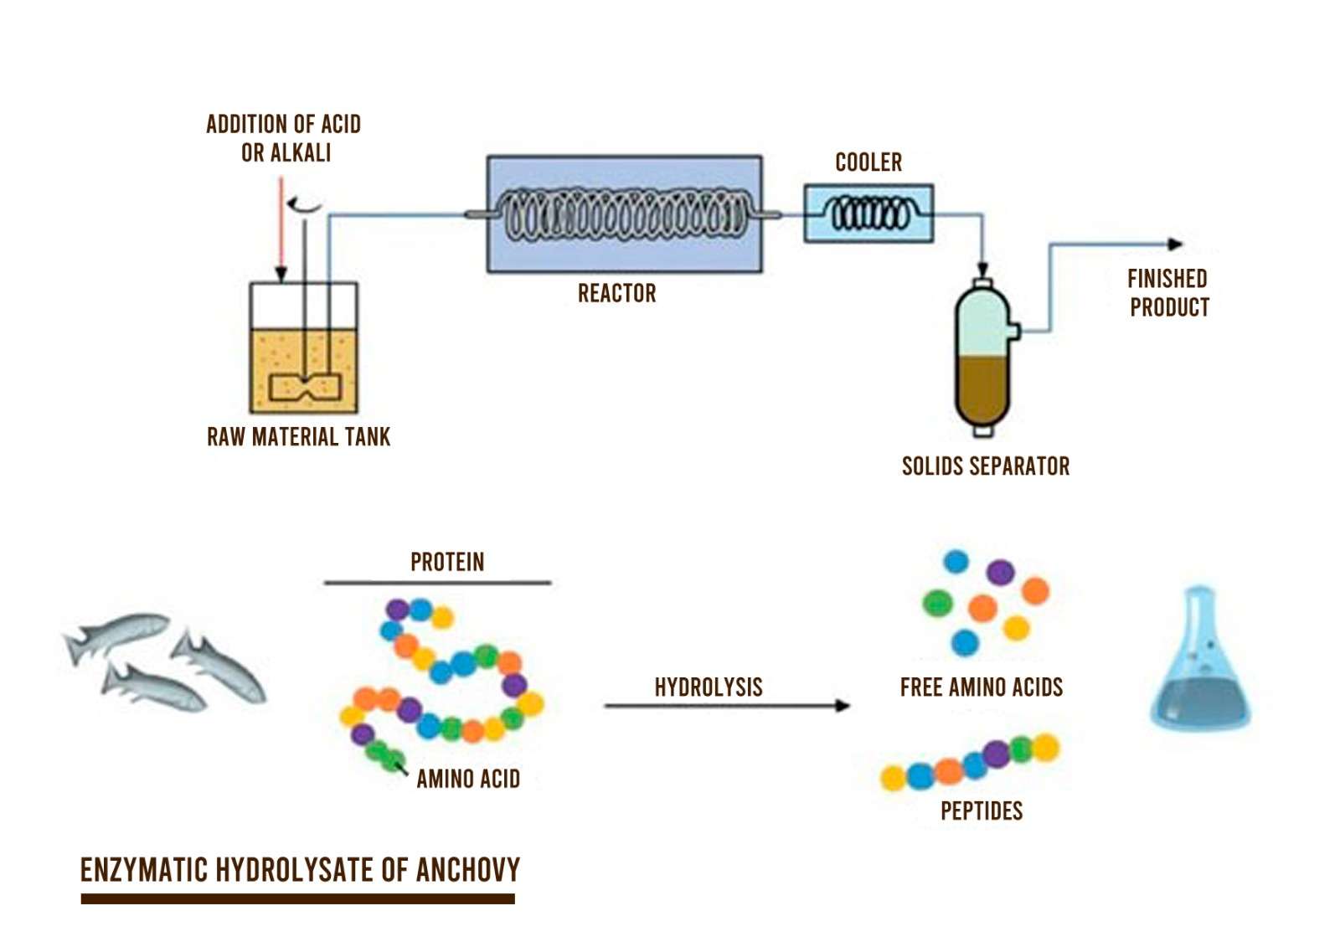

**Determination of hemoglobin level**

It was carried out by staff from the Chosica Hospital, 15 children from the application school

* 1. Results and Discussion

**Tabla 1**

*Results of the proximate analysis (Physical-chemical)*

|  |  |
| --- | --- |
| Total Ash (g/100 g of original sample) | 1.6 |
| Crude Fiber (g/ 100 g. of original sample) | 0.9 |
| Fat (g/100 g of original sample) | 20.3 |
| Carbohydrates (g/100 g of original sample) | 59.6 |
| Moisture (g/100 g of original sample) | 7.6 |
| Protein (g/100 g of original sample) (Factor:6.25) | 10.9 |
| Total Energy (Kcal/100 g of original sample) | 464.7 |
| % Kcal. from Carbohydrates | 51.3 |
| % Kcal. from Fat | 39.3 |
| % Kcal. From proteins | 9.4 |

**Tabla 2**

*Results of microbiological analysis*

|  |  |
| --- | --- |
| Number of *E. coli* (NMP/g) | Less than 1 |
| Number of Mohos (UFC/g) | Less than 3 (Estimate) |
| Number de *Staphylococcus aureus* (NMP/g) | Less than 3 |
| Determination of *Salmonella sp*. (in 25g) | Absence |

Biscuits enriched with enzymatic hydrolysate of anchovy were subjected to a degree of acceptability using the hedonic scale with a panel of 15 consumers of preschool age.

**Tabla 3**

*Acceptability level of biscuits enriched with enzymatic fish hydrolysate*



Based on the results, the 36-month-old students who tasted the biscuits fortified with enzymatic hydrolysate of anchovy, the formula that has 8% have a higher acceptability compared to the biscuits fortified with 10 and 20% of enzymatic hydrolysate of anchovy. Regarding the acceptability, 93.33% of the tasters stated that they loved the biscuits that contained 8% of the enzymatic hydrolysate of fish.

**Tabla 4**

|  |  |  |
| --- | --- | --- |
| Determination of hemoglobin level in children aged 36 months | | |
| Hemoglobin Level (in g/dL) | At the beginning of cookie consumption | 45 days after the start of cookie consumption |
| 10.6 a 11 | 8 | 2 |
| 11.1 a 12 | 4 | 6 |
| 13.1 or more | 3 | 7 |
| Total | 15 | 15 |

After 45 days of daily consumption of a 35-gram cookie fortified with anchovy enzymatic hydrolysate, all 36-month-old children increased their hemoglobin level, as the cookie enriched with anchovy enzymatic hydrolysate provided them with iron and amino acids from high Andean cereals such as cañihua, kiwicha and quinoa and free amino acids from the enzymatic hydrolysate of anchovy fillets.

* 1. Conclusions

One of the problems with the consumption of the cookie is the strong aroma given off by fish considered blue, such as anchovy, bonito, tuna and others, due to fatty acids such as omega 3. These fish have more fat than the so-called white fish, as they prefer cold waters, but these fats are healthy to the extent that they are predominantly unsaturated, that is, heart-healthy, since they have a large contribution of fatty acids, including the highly prized omega 3 that has the power to reduce cholesterol and triglycerides in the blood. Enzymatic hydrolysate of fish provides high-quality proteins, since it contains all the essential amino acids, especially lysine, essential for the growth of children and tryptophan, which helps regulate serotonin levels in the brain, therefore, calming and promoting sleep.

The acceptability test of the biscuit determined that the maximum content of enzymatic fish hydrolysate in the biscuit was 8%, so that children would consume the biscuit without being rejected by the strong smell and taste of blue fish. The biscuit was also validated in other settings such as school fairs and craft fairs in different locations in Peru and practice advises that between 5 and 6% of the enzymatic fish hydrolysate ensures the consumption of the biscuit, as some people have more developed taste buds and are more sensitive to the characteristics of the aroma of fish.

The daily consumption of a 35-gram cookie allows children to increase their hemoglobin levels, but it is necessary to carry out workshops and training with parents, teachers, local and regional authorities and students, on healthy eating habits and food education.,

References

Bender A., 2006, Dictionary of nutrition and food technology <[sciencedirect.com/book/9781845690519/benders-dictionary-of-nutrition-and-food-technology](https://www.sciencedirect.com/book/9781845690519/benders-dictionary-of-nutrition-and-food-technology)> accessed 12.02.2022.

Contreras L., 2015, Desarrollo de una galleta dulce enriquecida con harina de quinua blanca (Chenopodium quinoa) utilizando diseño de mezclas [<repositorio.lamolina.edu.pe/handle/20.500.12996/1928](http://repositorio.lamolina.edu.pe/handle/20.500.12996/1928)> accessed 23.02.2022.

He S., Franco S., Zhang W., 2013, Functions, applications and production of protein hydrolysates from fish processing co-products (FPCP), Food Research International, 50, 289-297.

Hleap J., Gutiérrez C, 2017, Hidrolizados de pescado – producción, beneficios y nuevos avances en la industria: una revisión, Acta Agronómica,66, 311-322.

ICMSF, 1983, Microorganisms in Foods, International Commission on Microbiological Specifications for Foods <icmsf.org/publications/books/> accessed 19.02.2022.

INDECOPI, 2016,Panadería, pastelería y galletería, Instituto Nacional de Defensa de la Competencia y de la Protección de la Propiedad Intelectual <gob.pe/13452-acceder-al-catalogo-virtual-de-normas-tecnicas-peruanas-y-textos-afines> accessed 26.02.2022.

INDECOPI, 2018,Bizcochos, galletas y pastas o fideos, Instituto Nacional de Defensa de la Competencia y de la Protección de la Propiedad Intelectual <gob.pe/13452-acceder-al-catalogo-virtual-de-normas-tecnicas-peruanas-y-textos-afines> accessed 19.02.2022.

IMARPE, 1996, Compendio Biológico Tecnológico, Instituto del Mar Peruano <repositorio/imarpe.gob.pe> accessed 25.02.2022.

INEI, 2020, Encuesta Demográfica y de Salud Familiar, Instituto Nacional de Estadística e Informática <inei.gob.pe/media/MenuRecursivo/publicaciones\_digitales/Est/Endes2019/> accessed 29.01.2022.

Khantaphant S., Benjakul S., Ghomi, M., 2011, The effects of pretreatments on antioxidative activities of protein hydrolysate from the muscle of brownstripe red snapper (Lutjanus vitta), Food Science Technology, 44, 1139 – 1148.

Meena, K., Tayal, D., Gupta, V., Fatima, A., 2019, Using classification techniques for statistical analysis of Anemia, Artificial Intelligence in Medicine, 94, 138–152.

Mengistu, G., Azage, M., Gutema, H., 2019, Iron deficiency anemia among in-school adolescent girls in rural area of Bahir Dar City Administration, North West Ethiopia, Anemia, 12,1–8.

MINSA, 2008, Norma Sanitaria que establece los criterios microbiológicos de Calidad Sanitaria e Inocuidad para los alimentos y bebidas de consumo humano, Ministerio de Salud <[minsa.gob.pe/norma\_consulta/Proy\_RM615-2003.pdf](http://www.digesa.minsa.gob.pe/norma_consulta/Proy_RM615-2003.pdf)> accessed 08.02.2022.

MINSA, 2011, Norma Sanitaria para la Fabricación, Elaboración y Expendio de Productos de Panificación, Galletería y Pastelería, Ministerio de Salud <<http://www.digesa.minsa.gob.pe/orientacion/NORMA%20DE%20PANADERIAS.pdf>> accessed 02.03.2022.

Odunlade, O., Adeodu, O., Owa, J., Obuotor, E., 2019, Iron deficiency, still a rarity in children with sickle cell anemia in Ile-Ife, Nigeria, Hematology, Transfusion and Cell Therapy, 41, 216–221.

Poma, S., Sánchez, P., Suárez, R., Jhoncon, J., Isidro, R., Vargas, E., Topalaya, C., Chambilla, M., Condore, L., 2023, Educación Alimentaria, Galletas de Atún y Anemia en niños menores de 5 años San Genaro-Chorrillos, Qantu Yachay, 3, 167–185.

Roldán, A., Omote-Sibina, J., Molleda O., 2021, Elaboración de un hidrolizado de proteína de anchoveta (Engraulis ringens) en polvo, Anales Científicos, 82, 251–261.

UNE, 2022, Código de Ética para la Investigación Universitaria de la Universidad Nacional de Educación Enrique Guzmán y Valle, Universidad Nacional de Educación <[une.edu.pe/investigacion/wp-content/uploads/2022/04/Resolucion-N%C2%B0-3314-2019-R-UNE.pdf](https://www.une.edu.pe/investigacion/wp-content/uploads/2022/04/Resolucion-N%C2%B0-3314-2019-R-UNE.pdf)> accessed 15.02.2022.

Zavaleta, N., Astete, L., 2017, Efecto de la anemia en el desarrollo infantil: consecuencias a largo plazo, Revista Peruana de Medicina Experimental y Salud Pública, 34, 716-722.